Graphic
Design
Proposal
Template
Prepared for:
[Client Name], [Company Name]
Prepared by:
[Sender Name]. [Sender Company]
Prepared on: 2022-01-11
Valid until: 2022-01-11

Intro

Dear [Client.FirstName],

Thank you for considering [Agency Name] for this graphic design project. We’ve reviewed the project brief and we confirm that we’ll be able to deliver our work within the specified time frame and budget.

In this graphic design proposal, you’ll find information about our creative process and the project costs. In case you need any further information, please, email us directly or book a time for a call. To confirm acceptance of the proposal return a signed copy of this document.

Thank you!

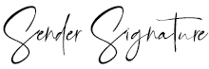

[Sender Name]

Project Overview

We understand that the [Client Company] would like to refresh its brand identity. It needs a new logo design, corporate design style guide, and new website design. [Agency Name] has extensive experience with graphic design projects for fintech businesses. We have worked with companies from the industry on numerous occasions, developing their brand outreach, attracting new clients, ultimately supplementing their business growth. We believe that we'll be able to deliver the same high results for the [Client Company], should you choose to work with us.

We're going to work closely with your colleagues from marketing in order to meet the deadline for this graphic design project. Here's a list of the deliverables that you can expect from us:

✔ New logo design
✔ New Letterhead Template
✔ New design for business cards
✔ New graphic design and illustrations for corporate gifts and promo items
✔ New website design concepts
✔ New social media design template

From our experience with companies from the fintech industry, we know that it's really important that your brand delivers the right message to your clients, that it's quickly recognizable and that it brings a unique appealing.
Trust us with your project and you'll be astonished by the result.

This is the Assessment section. In this section, you have to analyze the strength and weaknesses of the client’s current brand design, brand identity, website, etc. You can also include data about marketing trends and review competitors’ brands.

Analyzing the competition will show your client that you're really doing your best to understand the environment they're operating in. At the same time, your will gain valuable business insides that will facilitate your creative work for the client project.

The Creative Team

Established in 2001 by John Smith [Agency Name] has developed as a boutique creative agency, which puts client success before everything.

Our main focus is on graphic design and we know our craft inside out. Along with that, we have a strong team of digital experts with years of active experience in digital marketing, advertising, and programming. We strive to be the best and we give our all to our clients because we know that their success is our own success story.

Whenever downtown don't hesitate to visit us at 910 S Los Angeles St, Los Angeles, CA 90015 for a hot coffee or to discuss your next big project.

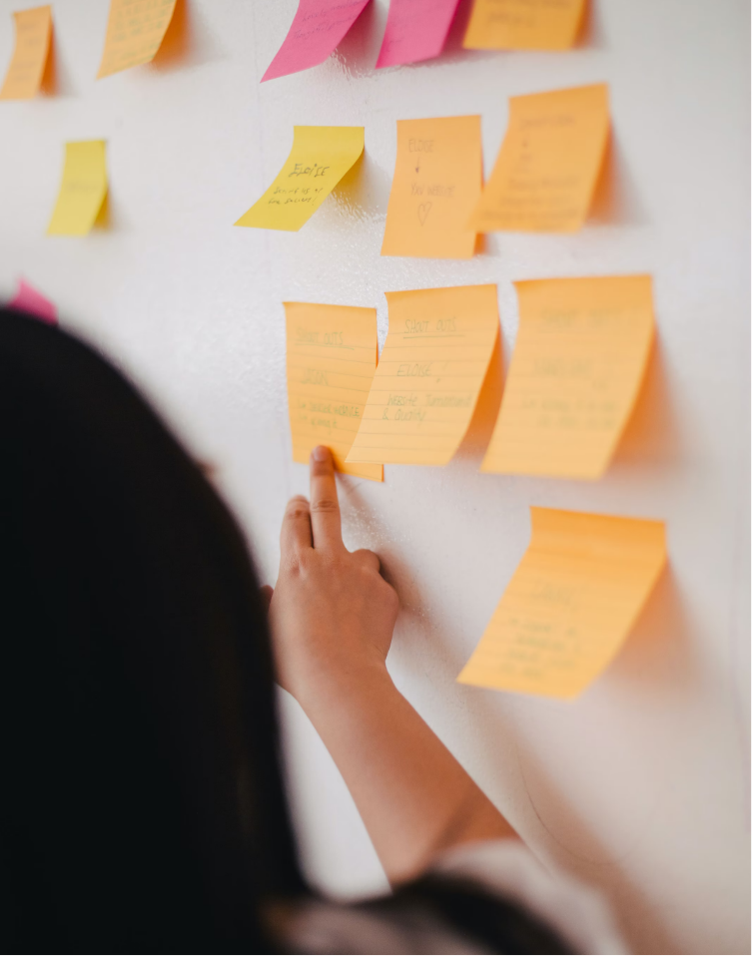

Our Work

When it comes to graphic design sometimes too many words may come in the way, when all you need to communicate are visuals. Here are some of the best projects that we have delivered for our clients.

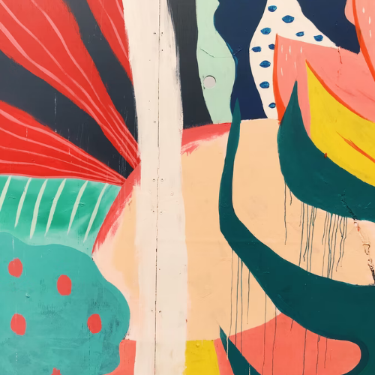  Project name  Graphic Design | 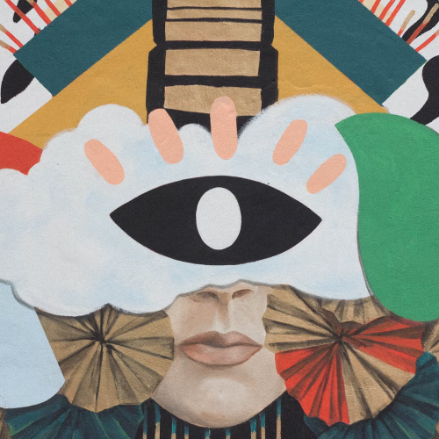  Project name  Graphic Design | 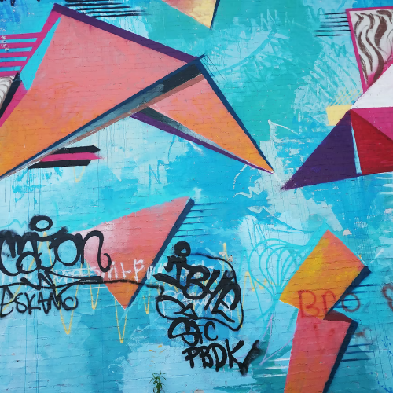  Project name  Graphic Design
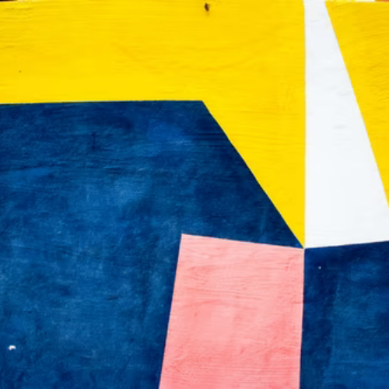  Project name  Graphic Design | 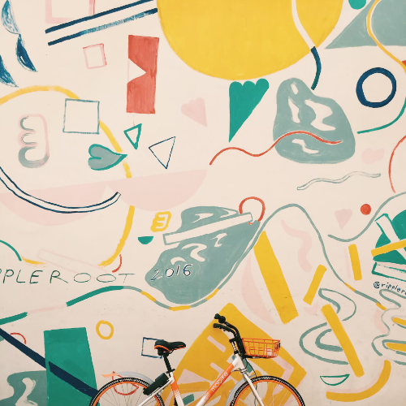  Project name  Graphic Design | 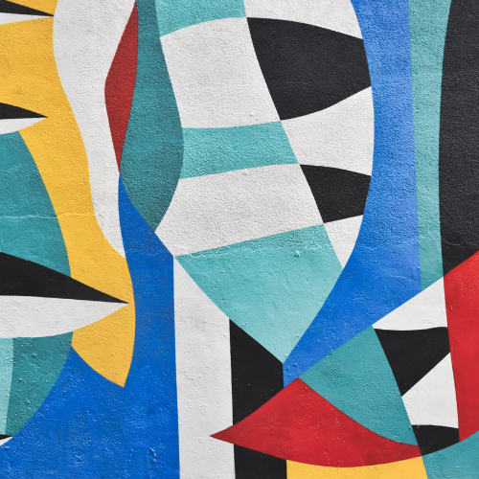  Project name  Graphic Design

This is just a small portion of our work. You can find more on our website.

View Full Portfolio

Client Testimonials

My experience with [Agency Name] really thought me how important it is to hire a professional and experienced graphic design team for your brand identity revamp. Brand identification is crucial in today's fast-paced business environment and [Agency Name's] focus and dedication towards our project lead to excellent results.

James Tony
BlueSocks

We definitely needed to refresh our brand identity. Our old website was generating no new leads and people were spending just a couple of seconds on it. We knew that we had to do something when we looked deeper into the stats. Luckily we found [Agency Name] and they held our hand all the way from ideation to the final web and graphic designs. Thank you, guys!

Adam Smith
Automation Inc.

I've never had the chance to experience such a lighting fast client service and communication style. The graphic design team at [Agency Name] is leaps and bounds above any other digital agency I've had the chance to work with. We worked on a tight budget and extremely short timeline and they managed to deliver quickly and efficiently on all points.

Gorge Batchelor
Edibles.tv

Process

Creative ideas need time to come to fruition. However, years of experience thought us how to be efficient with our time and always deliver before the client deadline. We know that time is money and we're committed that you don't waste any, working with us.

There might be differences in the delivery time for the various stages, but we'll always hit the end date right:

Stages | Timeline
Client Goals/Expectations | 5 days
Industry analysis | 5 days
Clearing Project Details | 4 days
Preparing Mock-ups | 6 days
Design Drafts | 10 days
Final Touches | 10 days
Programming and Printing | 20 days

Project Cost Breakdown

Name | Price | QTY | Subtotal
Brand identity consultation  Charged hourly | $100.00 | 10 | $1000.00
New Logo Design  Incl. 2 change requests | $500.00 | 1 | $500.00
Brand Identity Guideline  Incl. 2 change requests | $1000.00 | 1 | $1000.00
Promo items designs  Incl. 2 change requests | $500.00 | 1 | $500.00
Subtotal:  Government Tax 10%:  Total: |  |  | $3,000.00  $300.00  $3,300.00

Payment

We require a 50% upfront payment on the signing of the graphic design proposal. The balance is due upon project completion.

Total amount: $3,300.00

Net 15
Our accounts receivable team will expect all invoices to be paid within a 15 day period.

Bank Account Details
Bank name: Deutsche Bank Trust Company Americas, New York
Account holder: [Agency Name]
Routing number: 12345678
Account number: 85000000000123456

Address: 60 Wall St, New York, NY 10005, USA

Terms

[Agency Name] is going to work on your project as described in the project brief. Any additional requests for changes and additions will affect the delivery date and costs of the project. Any such additional work should be requested in a separate change order document.

The intellectual property rights over the creative and design work produced as a result of completing this project will be transferred to the [Client Company] as soon as the final payment for the work is completed. [Agency Name] keeps their right to showcase some of the designs in their design portfolio.

This document is our initial proposal to you. This is not the final agreement for the graphic design work we'll perform for you. We're open to discussing all project details to your complete satisfaction.

Your Signature

[Client Company]

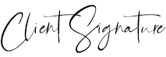

11 Jan 2022

[Client Name]

