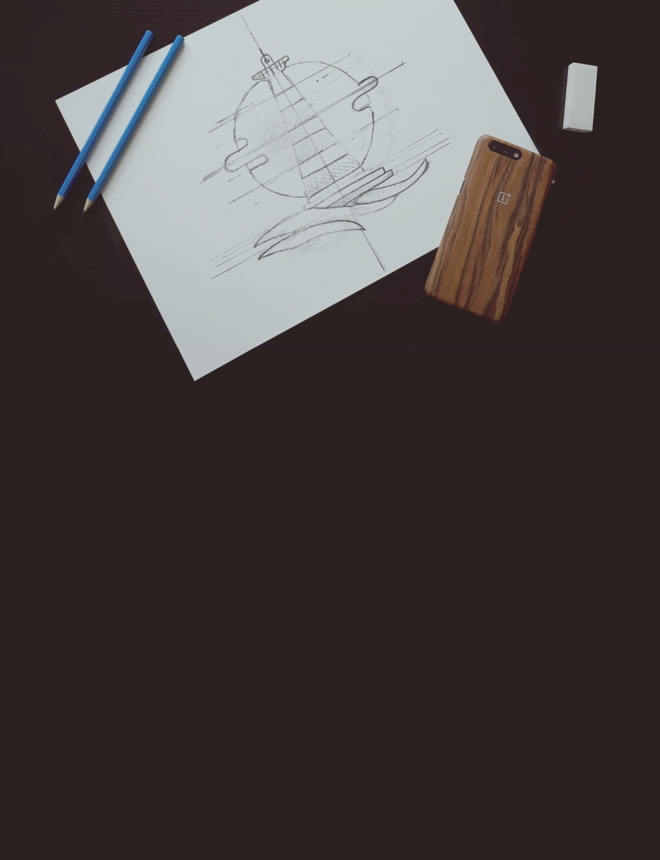

Logo Design
Proposal Template
Prepared for:  [Client Name], [Company Name] | Prepared by:  [Sender Name]. [Sender Company]
Prepared on: 2022-01-11 | Valid until: 2022-01-11

Introduction
Thank you for considering [Agency Name] for the design of your company logo. We know that you have plenty of options to choose from and we're glad to be given the opportunity to present our Proposal for your logo design project.
There are several different factors to consider when choosing a design agency for your logo design process. Experience, communication style, work process, delivery times, and pricing are the key components of the service provider assessment mix. In our Proposal, we'll touch on every one of them.

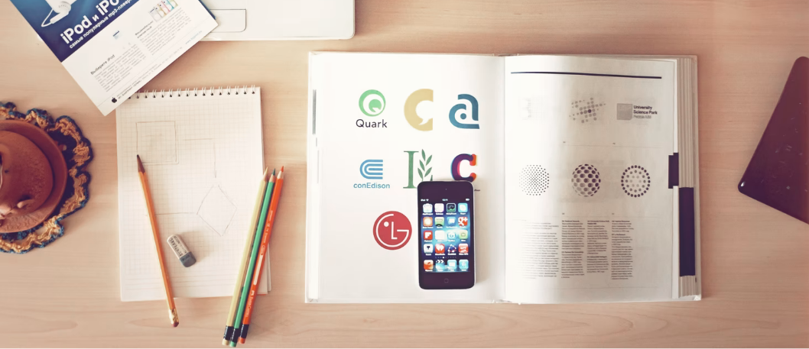

Our‌ ‌Work‌ ‌Process‌‌
The logo is the face of your brand. It's important that during the logo creation process we take our time and don't skip any of the creative steps. During the creative process, we'll be in constant contact with your team. We'll need your timely feedback and we'll rely on your comments and suggestions so we can capture the essence of your brand in the logo.

These‌ ‌are‌ ‌the‌ ‌main‌ ‌steps‌ ‌the‌ ‌logo‌ ‌creation‌ ‌process‌ ‌goes‌ ‌through:‌‌

1.‌ ‌Your‌ ‌Brand‌ ‌is‌ ‌Unique‌‌

We'll have to capture the unique identity of your company in your logo design. So we'll start with meeting your team to discuss the company's core values, goals, and key differentiators and how these can be depicted in a graphic form. We’ll hold a few brainstorming sessions to generate ideas for the logo design’s base components.

2. Mock-ups

After our meetings, we'll produce several mock-ups based on the ideas exchanged. You'll have time to review and consider those, before you commit to the version that we'll design.

3. Review & Revise

Once you decide which logo mock-up looks best to you we'll proceed with the actual design. When we're ready with the initial design, we'll make as many rounds of changes as needed before we create the final version.

4. IP Rights

Now that the logo design is ready, we'll share the source files with you and after the final payment is completed we'll transfer all intellectual property rights to your company.

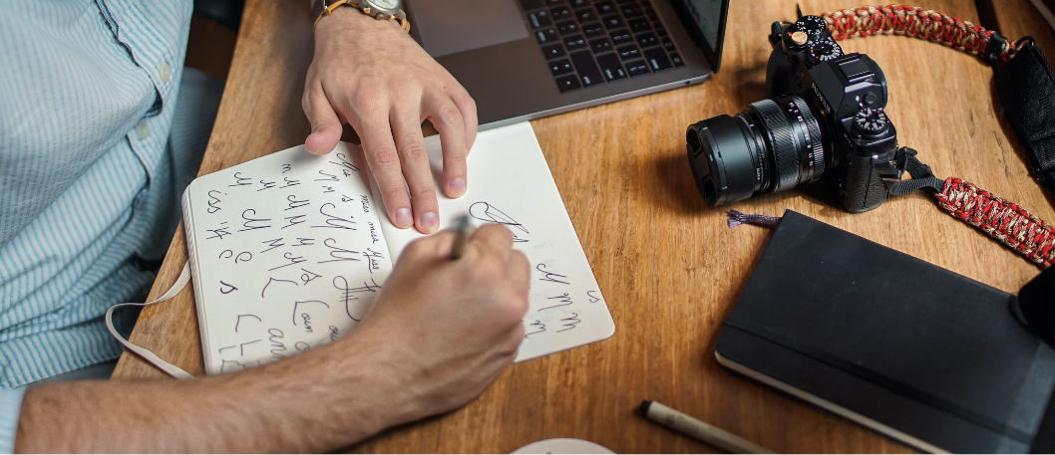

We‌ ‌Have‌ ‌the‌ ‌Experience‌‌
Here're a few good reasons why we think we're the right choice for your logo design project.

We won't leave you outside the creative process. We'll need your feedback and ideas on every step of the project, keeping you involved in your logo design. | We'll do our best to produce not just an eye-catching graphic design, but one that incorporates your brand's unique features.
Real graphic design professionals will be working on your logo design. And they won't budge until they create the perfect logo design for you. | We believe that communication is the key to any successful digital project. This is why we'll be providing constant updates on the project development.

Client‌ ‌Testimonials:‌‌

Here’s what some of our clients say about their experience with [Agency Name].

We are a small start up and we needed a quick solution for the logo of our new company. [Agency Name] were quick to respond. We met several times before they prepared the first mockups. We expected to have the logo done in a week, but when we started working with [Agency Name] we saw how much thought and effort they put into their work and we decided to give them the time they needed. Now we're extremely happy with our company logo. The result is worth every dollar spent.
Jessica Moore
VP of SmartTech Inc.

This was the third time we were rebranding our company in just 6 years. The company directors were not entirely happy with the results of the first two rebranding campaigns and they were right. When we started working with [Agency Name] we saw how the rebrand process looks when handled by real professionals. We've been explained all the stages the redesign process will go through and were provided with a timetable for the deliverables. [Agency Name] paid special attention and dedicated extra efforts to the creation of our new logo. We are very thankful for their guidance and dedication!

Christopher Smith
VentureCapital, Inc.

Price Quote

Here’s a breakdown of the price for the logo design process. We expect a 50% upfront payment before we start our work and the rest of the payment to be cleared when the project is completed.
Name | Price | QTY | Subtotal
Upfront payment - 50% | $0.00 | 1 | $0.00
Final payment - 50% | $0.00 | 1 | $0.00
New logo promo campaign | $0.00 | 1 | $0.00
Subtotal:  Government Tax 10%:  Total: |  |  | $0.00  $0.00  $0.00

Non-disclosure of project information

Any information exchanged during the work on your logo design will be considered confidential. Both parties agree to inform their teams that it’s strictly forbidden to share any project information with companies or individuals not engaged in this project.

Refund Policy

Although we require an upfront payment to start work on a logo design project, we require complete project payment only upon the client's full satisfaction. When the new logo is ready and you have the designs with you, you have 10 days to provide feedback and request changes. The project price provided in this Proposal includes an unlimited number of changes, so that the final result satisfies your expectations. If requested a refund can be issued during this 10 day period. If no such request is submitted to us, the project is considered accepted.

Accepting this Proposal

Please, take your time to review our Proposal and sign and return the document when ready to start work. Once we receive the signed document, we’ll schedule the first few meetings with your team.

[Agency Name]  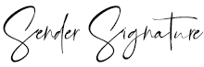  11 Jan 2022  [Sender Name] | [Client Company]  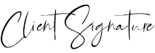  11 Jan 2022  [Client Name]

