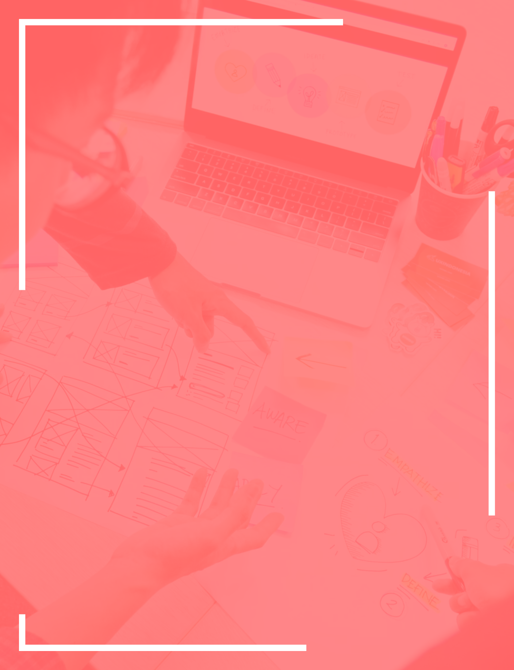
UX Design
Proposal Template
Prepared for:  [Client Name], [Client Company] | Prepared by:  [Sender Name]. [Agency Name]
Prepared on: 2022-01-11 | Valid until: 2022-01-11

Quick Intro

During the years [Agency name] developed as a boutique design agency. In any given time we work only on a handful of projects, however, we service companies from a wide range of industries. As your UX designer we'll prepare such UX design concepts for your web application or website that allow your users to interact with your brand, products and services in an easy and enjoyable way.

After our initial meeting we have put this UX design proposal together to sum up what we've discussed. Here we provide a UX design solution that we believe fits best your online project's goals. We explain our work process, we offer a schedule for the deliverables and we also include our price quote.
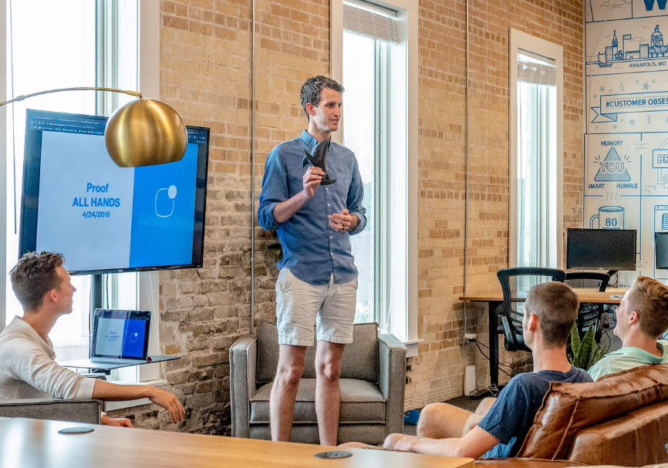
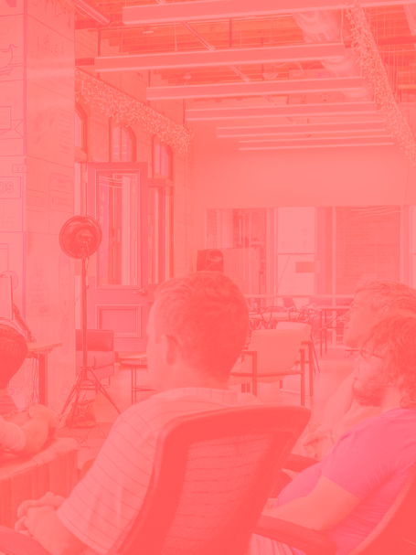
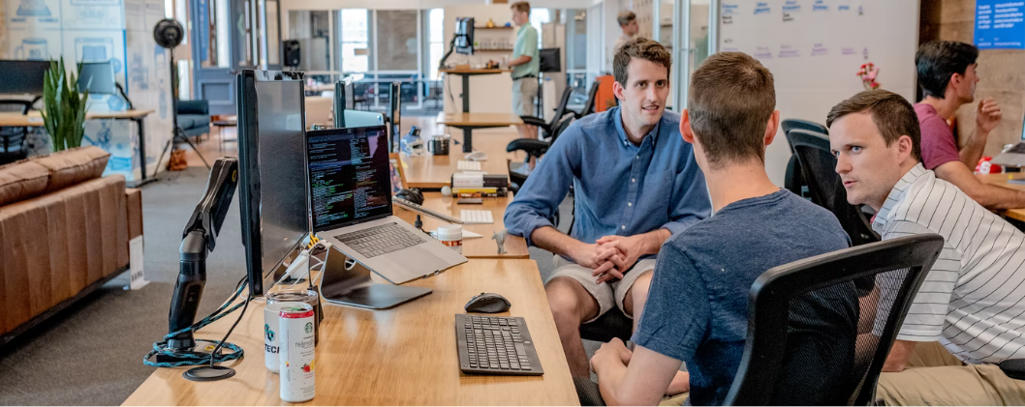

Happy Clients

When we see a happy client, we want to share his happiness with the world. Below are a couple of testimonials from clients we’ve worked with on UX design projects this year. Feel free to reach out to them to discuss their experience with us first hand.

Excellent service and client support! The [Agency name] team made the process of our UX design revamp easy and smooth. They listened to us actively, understood pretty quickly what we were after and delivered it on time.

Anthony Stack, Notorious Entertainment

All [Agency Name] needed from us was our project brief, which was quite brief indeed :) They developed the whole concept of our new UX design from just a couple of vague ideas. Really professional and truly creative team!

Virgil Knight, Virginia CarWraps

Goals & Solutions

In this section you have to describe your understanding about the client's project. Outline their goals and offer solutions to the unique challenges they face. Research their main competitors and offer ideas how to successfully compete against them with your UX design solutions. Show your clients that you have listened carefully during your meetings and calls with them, that you took notes and that your goals are in line with what the client wants to achieve.

Carefully explain how your UX designs will improve the interaction with your client's products/services, how this will lead to a more engaged audience, will improve conversion rates and ultimately bring in more sales.

Your time, efforts and expertise will help them achieve the following:

Explain in detail how you see their goals, which are the most important ones. Rank them and comment.

Our Process
Our experience in UX design shows that every successful project goes through these three steps:

Phase 1.  Research | Phase 2.  Design | Phase 3.  Changes
Review current UX challenges and competitors solutions. | Prepare UX design concepts and clear outstanding details. | Test and improve the UX design to perfection.

Phase 1.  Research | Our research team will review your current UX design, your services and your competitors, so we can answer the following questions:  - Who is using your products/services?  - How do your products satisfy your client's needs?  - What are your product goals?  - What do your competitors' UX choices look like?  This is the foundation of our future work and it's really important that it’s done properly.

Phase 2.  Design | This is the actual UX design creation stage. It goes through these three steps:  - UX design concepts to choose from  - Approved UX design concept  - Completed UX designs ready for testing

Phase 3.  Updates | At this stage, we'll perform a series of tests to validate our expectations for the new UX design's performance. Based on the results from the testing we'll discuss updates and adjustments needed for the fine tuning of the new UX design. If needed we'll go through this stage 2 or 3 times, until the final UX design is ready to be applied on your website, mobile or web application.

Project Schedule

This table shows the major milestones we'll have to reach working on your UX design project. It also shows the time allocated to complete each UX design stage. It's possible that some of the design stages are completed quicker or others take more time, however, we'll constantly keep an eye on the final delivery date.

Milestone | Date Reached
Phase 1 | 11 Jan 2022
Client Meetings | 11 Jan 2022
User Research | 11 Jan 2022
Competitive UX Analysis | 11 Jan 2022
Phase 2 | 11 Jan 2022
UX design mock-ups | 11 Jan 2022
Design Concepts | 11 Jan 2022
Design Approval | 11 Jan 2022
Phase 3 | 11 Jan 2022
Testing & Updates | 11 Jan 2022

Price Quote

Based on the requirements for this UX design project, here's a breakdown of our price quote:

Name | Price | QTY | Subtotal
UX Design Mockups - 50% | $0.00 | 1 | $0.00
UX Design Approval - 30% | $0.00 | 1 | $0.00
UX Design Deployment - 20% | $0.00 | 1 | $0.00
Subtotal:  Tax 10%:  Total: |  |  | $00.00  $0.00  $0.00

NDA & Payment Terms

During our work on this project some confidential information may be exchanged between [Client Company] and [Agency Name]. This is why we'll treat all information exchanged between the two parties as confidential information. No information exchanged during our work on this UX design project should be shared with third party individuals and/or companies and each party should take the appropriate actions to inform its employees about this non-disclosure clause.

All invoices issued by [Agency Name] will be in USD. Our payment term is Net30 and we expect all payments to be completed in USD. [Agency Name] accepts bank wire payments, PayPal and credit card payments.

Please, read carefully this Proposal and discuss its contents with your colleagues before you sign the document. We’re open to further talks in case [Client Company] would like to propose any changes or additions.

[Client Company]

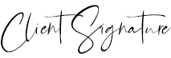

11 Jan 2022

[Client Name]

