 |  | Prepared on: 2022-01-11 Valid until: 2022-01-11

Web Design
Proposal Template
Prepared for:  [Client Name], [Company Name] | Prepared by:  [Sender Name]. [Sender Company]

Cover Letter

Dear [Client Name],

I would like to say first how delighted we're that you're considering [Agency Name] as a design partner for your next project. Out of over (x number) of design agencies in (city, state, or country), you've chosen [Agency Name] and we won't let you regret your decision. We've put together for you this detailed proposal which you can review and discuss with your colleagues.

Our main driver is that we believe in excellence and we strive to be the best. We work hard every day to deliver our projects on time and not exceed the quoted project price.

Furthermore, we know that your goals are our goals. If it was not for our clients we would not be where we're now. This is why we'll work closely with you to understand your main goals and help you achieve them through outstanding design. We'll help you increase your competitive advantages and win over new clients.

To make it easier to read and comment, we've divided this proposal into several points. We share our process, we outline solutions for your project's needs, we share testimonials from our clients, project delivery times, and costs.

This web design proposal is also an Agreement for the project execution. To speed up the design process, in case you decide to work with us, we've included a list of contract terms in the document. You have to just sign it and we'll be bound by the terms of this mutual agreement to deliver the project to completion for you.

[Sender Name]
[Agency Name]
[Agency Contacts]

Client Testimonials

It's always a greatest reward to hear the good words that our clients have to say for us. Instead of listening to what we say about our hard work and dedication, here are a couple of testimonials from clients that we've worked with within the past year. See what they say about their experience with us.

 | 🙶 | “We used to have a website that has not been refreshed for years. It was really old and did not scale for mobile at all. Along with that, it could not convert a single visitor into a prospective client. The website that [Agency Name] built for us is excellent. It looks great and runs as a proper marketing channel, sending leads to our sales guys on daily basis.”  — Tina Fey, Malcolm Industries
 | 🙶 | “Our new website came about great and we owe a big Thank you! to [Agency Name]. But not just that, they also deliver excellent post-development support. We constantly change and experiment with content and new functionalities and they are quick to implement every request we throw at them. Their monthly visitors’ reports are invaluable and complement our marketing team's efforts.”  — Jonathan Strand, Fiscal Electronics

We're honored to be the web design partner of choice for a wide variety of businesses, who decided to invest in their online expansion.

- Relocation Pros  - Pacific Travel  - Federal Agency  - Golden Solutions  - Head Start  - Message Mavens  - Speedy Getaways  - Emoville Agency | - Royalty Travel Systems  - Scirizon Media  - Nexus Marketing  - Hype Advertising  - Pegasus Travel Agency  - Accurafind Agency  - Catered Career  - Target The Pitch

Website Development

We developed the proposed web design based on the discussions we had with your marketing team. We believe that it fits perfectly with your brand identity. It will enforce your marketing message, it will keep visitors longer on your website, and will help you convert them into prospective clients more efficiently.

Website structure:

Homepage
This is the main page of your website, which will show your main message, client testimonials and links to your services.

About Page
This page will tell your company story and will show how you built your team and business.

Services Page
These will be various pages showing the services you offer, listing details, pricing and service advantages.

Contact Page
This page will show a short contact form, company address, phone number and email address.

We'll also build these few important features and functionalities for your website:

Traffic Monitor
We'll integrate your website with a service that will allow you to monitor your website traffic. This way you'll be able to monitor your client's behavior on your websites, identify hidden trends and keep track of acquisition data.

Marketing Automation
We'll set you up with a service that will automate your weekly email bulletins and social media posts. You will be able to feed your account with email templates and social media posts and set up dates and times for publishing.

Interaction Heatmap
This service will allow you to see how your users interact with your website. Which links, menus, and pages they hover over or visit first. Which parts of your home and inner pages their attention is most attracted to.

[Agency Name] is one of the leading WordPress development agencies in (city or state) and we think that integrating your website with WordPress is the best option for you. Once your website is launched and our work is done, your team will be able to maintain the website by themselves. The WordPress admin panel is not only easy and convenient to work with, but the integration will save you on future website support.

Development Schedule

Based on our experience with web design and web development projects we have created the below web development schedule. It helps us to structure our work around the project tasks in the most efficient way.

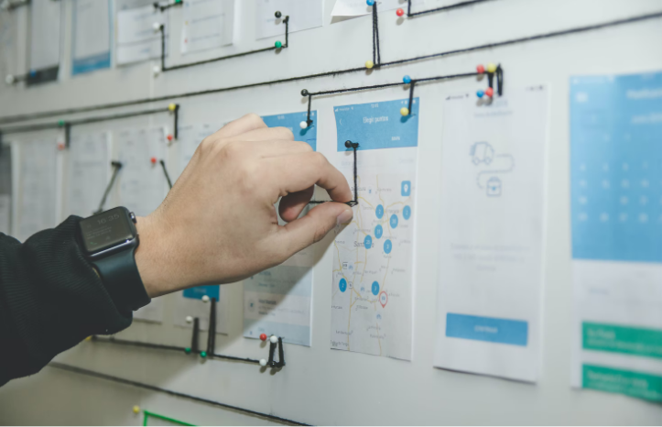 | Project Roadmap  First, we'll sit together with all stakeholders to put a detailed list of all project requirements. We'll identify the major milestones to follow, so we can keep an eye on what comes next and be able to assess our progress.
⇓
Wireframes  At this stage, you'll have the chance to see what your future website will look like. The wireframes are not as detailed as the final designs, however, they give a good idea about what the general layout of the website will be. | 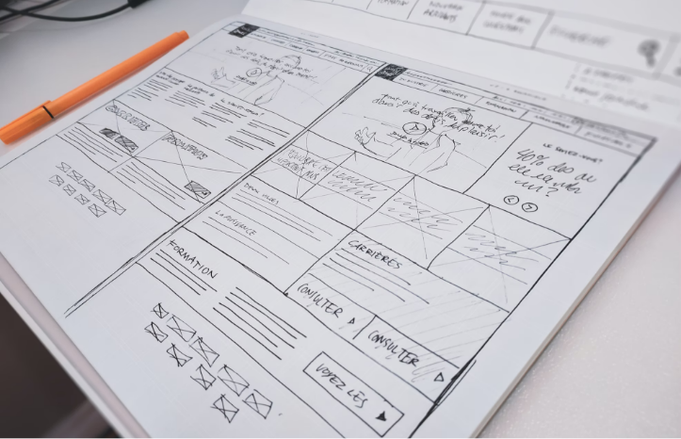
⇓

Design Versions

We'll present you with a couple of design versions. Once you pick up one of them we'll make as many tweaks and changes as needed in order to reach to the final website design.
⇓
Texts & Images  As soon as the website design is ready, we'll need the copy for the website and we'll have to purchase the images for it. If you have a photographer you're working with you may arrange a photo shoot with him. | 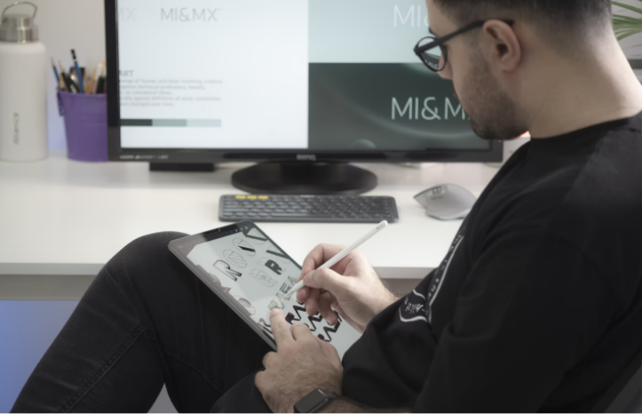
⇓
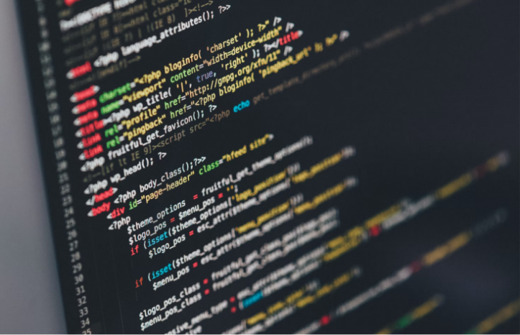 | Web Development  While you're working on the copy and sourcing the images for the website, we'll start with the coding work. We'll do the front-end development and the WordPress integration.
⇓
Testing  In the end, to makes sure that every menu and every functionality on the website work as expected, we'll hand the website to our quality assurance team. Along with that, we'll also ask you to have a look at the website with your team and report any bugs you may find. | 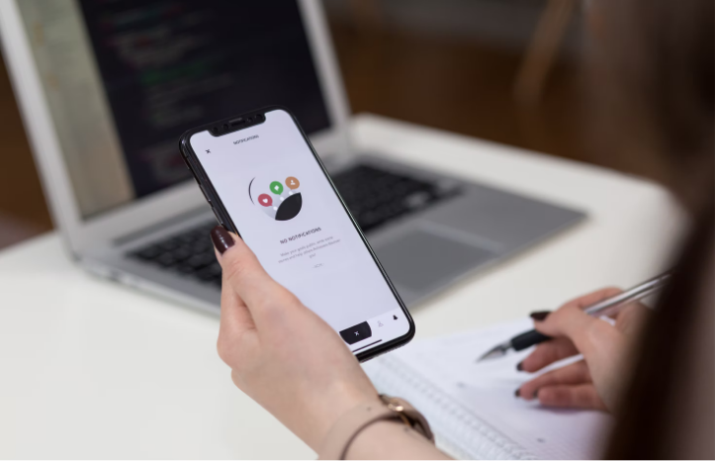

Project Schedule

Based on our experience and the understanding that we have for your project now, here's how much time each development stage will take.

Milestone | Date Reached
Project Roadmap | 11 Jan 2022
Wireframes | 11 Jan 2022
Design Versions | 11 Jan 2022
Texts & Images | 11 Jan 2022
Web Development | 11 Jan 2022
Quality Assurance Stage | 11 Jan 2022

Price Quote

Here’s a breakdown of the project costs:

Name | Price | QTY | Subtotal
Upfront Payment - 50% | $0.00 | 1 | $0.00
Milestone 1 - 30% | $0.00 | 1 | $0.00
Final Payment - 20% | $0.00 | 1 | $0.00
Subtotal:  Government Tax 10%:  Total: |  |  | $00.00  $0.00  $0.00

Contract Terms
[Agency name] agrees to develop the website for [Client Company] as per client's specifications. Any changes or additions outside the scope of this agreement may delay the final delivery of the project and alter the project costs. Such changes should be agreed upon in a separate agreement, before going into effect.
The project invoices will be issued as per the payment schedule in this document. [Agency Name] will expect the payment of the invoices within a 14 day period from the date of issue. [Agency Name] accepts bank wire payments, company credit card payments, and PayPal payments.
Upon final payment, all rights over the newly developed website and all its assets become property of [Client Company]. [Agency Name] will be allowed to showcase the client's website in its work portfolio.

[Agency Name]  11 Jan 2022  [Sender Name] | [Client Company]  11 Jan 2022  [Client Name]

