Website
Development
Proposal
Template
Prepared for:
[Client Name], [Company Name]
Prepared by:
[Sender Name]. [Sender Company]
Prepared on: 2022-01-11
Valid until: 2022-01-11

Our Proposal

We understand how hard it is to find the right web development partner and we're glad to know that you have chosen [Agency Name] to work with you on your web development project.

We're a team of professionals and we do our best to satisfy our clients' needs and expectations. Our team consists of web developers and designers with 7+ years of active experience and they are all located in our office in (City, State). We don't work with freelance contractors.

We have a long list of successful projects with brands located in the US, Europe, and Asia. We understand your regional specifics and we're really excited to be working with you.

We have listed some of our best work in the Proposal. You'll see which companies we have worked with and what type of web development we've performed for them. If you think that we're the right fit for you and you decide to trust us with your project, just sign the Proposal on the last page and return it to us.

Thank you very much for considering our offer!

[Agency Name]
[Sender Name]
[Sender Position]
[Sent Contacts]

About Us

[Agency Name] was established in 2010. We started as a couple of fresh out-of-the-college programmers and managed to build a team that is now one of the most reputable agencies in (enter city name).

We have completed hundreds of projects during the past 11 years. Big and Small. Easy and Complex. Paid and pro bono.

We are never afraid to fail if this will lead us to learn something new and expand our professional and personal horizons.

We believe that communication is crucial for the successful completion of our projects. This is why we listen carefully to our clients and we welcome their feedback on every stage of the web development process.

Our project managers will be available to discuss your questions and suggestions at any time, via phone, email or in person in our office at (office address).

Project Scope

The new website we'll build for the [Client Company] will allow you to reach a wider audience and will present the value you bring to your clients in a modern and more engaging way. The organic traffic to the website will increase, which should improve your conversion statistics.

[Agency Name] has extensive experience with companies from your industry, which puts us in a position where we can bring much more to your project than any other web development agency.

Project Examples

Here are few examples of our work that might be interesting for you:

Project 1:  After their rebranding campaign, we built the website of this major fintech company. We integrated the new website with WordPress, which allowed the client to keep the content management of the website with them.  More details | 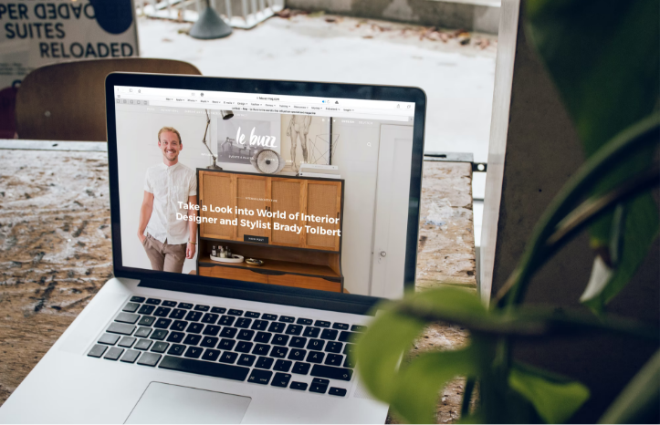

Project 2:

We're really proud that we've had the chance to work with one of the leading companies in the autonomous vehicles industry. We built their website from scratch and worked closely with their branding and marketing teams to make sure that the website conveys the right message to the visitors, transforming them into potential buyers.

More details

Our Solution

As we specialize in website integrations with WordPress, we suggest that your website is built with that CMS. It's one of the most well-known, highly developed, and advanced content management systems, which will allow you to easily maintain your website and let it grow where your needs lead you. Here're the most important advantages you get from building your website with WordPress:

- WordPress is free
- Managing your website content is fast and simple
- Using plugins to enhance your website functionality is much cheaper than custom development.

We suggest that you pick a solid hosting company like (hosting company name) so that they can ensure that your website will be able to handle any future traffic increase and that the website will be protected against external attacks.

Site Structure
This is how your website will be structured:

- Home
- Services
- Reviews
- Partnerships
- Inner page 1
- Inner page 2
- Inner page 3

Service Integrations
We'll integrate your website with these three important services:

- WordPress
- Google Analytics
- HotJar

These three services will allow you to keep track of the user flow to your website, identify niche market opportunities and turn your new website into the ultimate online sales tool.

Enhanced Performance
In order to use the potential of your website to the maximum, we'll also develop these three functionalities for it:

- Online Cost Calculator
- LiveChat Bot
- API

Progress Timetable
These are the main stages the website development will go through and the timeline of the project:

Stage | Completion Date
Project Scope | 11 Jan 2022
2 x Design Versions | 11 Jan 2022
Design Approval | 11 Jan 2022
Website Development | 11 Jan 2022
Changes and Additions | 11 Jan 2022
Completing Development | 11 Jan 2022
Quality Assurance Stage | 11 Jan 2022
Official Launch | 11 Jan 2022

Disclaimer: The dates for the delivery of each stage are estimated based on our previous experience with projects like yours. Having this in mind, we're keeping our right to adjust any of these dates once we have the final and complete list of project requirements with us.

Price Quote
Below is our Price Quote for your project. Any invoices issued by [Agency Name] can be paid via bank transfer, company credit card, or PayPal. Payment is expected within 14 days of the invoice issue date.

Name | Price | QTY | Subtotal
Upfront Payment - 50% | $0.00 | 1 | $0.00
Mid-project Milestone - 30% | $0.00 | 1 | $0.00
Final payment - 20% | $0.00 | 1 | $0.00
Subtotal:  Government Tax 10%:  Total: |  |  | $00.00  $0.00  $0.00

Milestone Fees
Once the website is live there will be some maintenance fees associated with its operation.

Name | Price | QTY | Subtotal
Monthly Technical Support | $0.00 | 1 | $0.00
Third-party Services Fees | $0.00 | 1 | $0.00
Subtotal:  Government Tax 10%:  Total: |  |  | $00.00  $0.00  $0.00

Confidentiality
All information exchanged between [Agency Name] and [Client Company] is considered confidential information. Both sides need to take the necessary steps to guarantee that any information exchanged stays confidential and that it's used only for the purpose of this project. Confidential information does not include information that is already in the public domain or might become public during the course of the work on this project.

Proposal Terms

1. Independent Contractor
[Agency Name] is hired by the [Client Company] in its capacity as an independent web development firm to provide the services of design, development, and deployment of their future website.

2. Invoicing & Currency
All invoices will be issued in USD and are expected to be paid in USD, within 14 days of the invoice issue date.

3. Launch Date
[Agency Name] will do its best to complete the project in the agreed timeframe and launch the website before or on the agreed launch date (enter launch date here). In order to meet its deadline [Agency Name] rely on [Client Company] that it will stay actively engaged in the project communication and will reply to all questions submitted by [Agency Name] in a timely manner.

4. Subcontracting
Agency Name is allowed to, but not required to, hire subcontractors in order to fulfill the project requirements and deliver the completed project on time.

5. Change Requests
Any changes to the Project Scope will be billed separately and will be agreed upon in a separate contract. Such changes may delay the launch date of the website.

6. Severability
The terms of this contract are independent of one another. If one or more of its terms are found to be unenforceable, the rest of the contract will remain in force.

7. Third-Party Rights
[Agency Name] guarantees that any graphics, images, texts, plug-ins, or add-ons used in the project are owned by the [Agency Name] or that their use is paid for to the rightful owner. In case of breach of a third party's rights, [Agency Name] agrees to indemnify [Client Company] against all costs and damages that may arise from such breach.

8. Transfer of Copyrights
All copyrights over the final project will be transferred from [Agency Name] to [Client Company] as soon as the final payment is completed. [Agency Name] keeps the right to show the client's website as part of its portfolio.

9. Entire and Sole Agreement
This agreement is the entire agreement between the two parties and the only agreement in regards to this web development project. Any changes in scope or price must be outlined in a new, separate document and agreed upon by both sides.

10. Refund Policy
[Agency Name] works for the client's full satisfaction. If for any reason [Client Company] is not satisfied by the website development work delivered by [Agency Name] it has the right to request a refund within 14 days of the last project delivery. After the 14th day, it is considered that the web development work is accepted as is by [Client Company].

[Agency Name]  11 Jan 2022  [Sender Name] | [Client Company]  11 Jan 2022  [Client Name]

