Website
Redesign
Proposal Template

Prepared for:
[Client Name], [Company Name]

Prepared by:
[Sender Name]. [Sender Company]

Prepared on: 2022-01-11

Valid until: 2022-01-11

Intro
Dear (Client Name),

It was great meeting you and the team last week and thank you for taking the time to talk to us! We discussed your project with our web designers and we'll be happy to work on the redesign of your website. We have been able to identify some problematic areas of the current design, which will be solved in the newly redesigned version of your website.

This website redesign proposal provides detailed information on our workflow, project costs, project stages and provides innovative solutions for the unique challenges you’re facing with your current website.

Regards,

[Sender Name]

Project Goals

[Client Company] would like to redesign its website, so it accounts for the new trends in website design, attracts more users to its services, and help with the growth of its client base. [Client Company]'s growth has reached a plateau, but the company directors are taking proactive measures so that the [Client Company] regains its position as a market leader. To achieve these important business goals the company needs a complete overhaul of its current website.

We're proud to say that through our web design service we have helped many successful businesses to increase their retention and conversion rates, improving their growth and overall market position.

We'll prepare a list of areas of improvement that we think are necessary and we'll discuss those with the [Client Company]'s marketing and sales teams. [Client Company]'s feedback will be very important as it will help us better understand what motivates the most your clients and how to present your services/products in the most desirable way online.

Identifying Problems

We know that every company has its unique challenges and we expect that [Client Company] will help us assess its current situation and the challenges it faces now. This will help us to identify those problems which we can overcome through the website design and we'll offer solutions that you will have to discuss with your team and approve. Nothing in our work is irreversible. Even if we apply changes that don't work in favor of our final goal, we can always dial back, reassess the situation and come up with a different solution.

Website Redesign Process

Our main goal is that you're fully satisfied with the end result of our work. This is why we'll do our best to create a website design that is appealing to the eye, as well as easy to use, and reaches the goals set in terms of increasing retention and conversion numbers. For the size of your website such projects usually take 3-6 months, depending on the test and iterate stage. We'll work hand in hand with you to create the best possible website for you, this is why it's important that we can communicate with your team quickly and openly. Below is a breakdown of how much time every stage of the website redesign process will take. If you wish to comment on any of these, please, let us know.

Objective | Timeline
Project goals | 1st — 7th day after signing
Wireframes | 7th — 12th day after signing
2 design concepts | 12th — 15th day after signing
Design approval | 15th — 22nd day after signing
Round of changes | 22nd — 35th day after signing
Final design & testing | 35th — 50th day after signing
Website launch | 50th — 70th day after signing

Design Workflow
Here are the redesign stages we’ll go through in a bit more detail.
First We Plan | Based on our first discussions with you we're going to identify the problems with your current website design and find solutions to those problems.  - Identify problematic areas  - Research competitors' websites and see what solutions they’ve applied  - Work out solutions to apply in your project
Web Development | When the web design is ready, we continue with the coding of the new pages.  - Front-end development  - WordPress integration  - Website migration  - SEO optimization
Quality Assurance | During this phase, we'll have our QA team play around with the new website and test all the newly developed forms, functionalities, and menus. This phase does not include additions to the project scope, but only finding and solving existing code bugs.
Launch Phase | After the testing phase is completed and all code inconsistencies are fixed, it's time for the launch of the new website.  This is the moment to think about your marketing plan for the website launch. This service is not included in this Proposal, however, we can discuss your needs in this direction and agree to work on your marketing strategy in a separate agreement.

Website Support

Now that your new website is ready and launched life, we can continue supporting it, so we can enhance the value of your online presence. There are several different directions we can focus our efforts in. You can choose either one or a combination of services that suits your goals best.

Traffic Analisys  We'll monitor and analyze your traffic data to identify hidden trends and revenue streams that are currently untapped. | Marketing  Email marketing and blogging are very strong marketing tools, which may help you attract new clients and increase retention rates. | Offline  If you want to advertise your services online to acquire paid traffic, we can organize and manage the paid campaigns for you.

The Team

Since [Agency Name] was established in (year), we've always been focused on quality over quantity. As we understand the importance of our clients' success through the website design and development services we offer, our only goal is to see our clients happy with the results of their collaboration with us. Part of our team is consisted of creative professionals working on web and graphic designs, while the other part is analytical thinkers handling programming and web development. All our colleagues are located in-house and we don't outsource work to third-party providers.

Our goals are your goals, and your success is our own success story.

Portfolio

We're servicing a wider range of companies, from online-based businesses to hotel chains and car dealerships. We've obtained the content of some of our best clients to showcase their projects with us. Some of them are listed below. If you want to see specific examples of our work please, let us know.

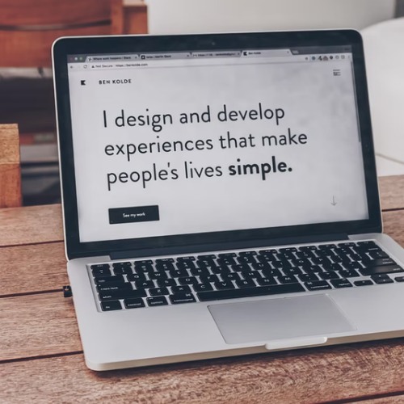  Project name  Website Redesign | 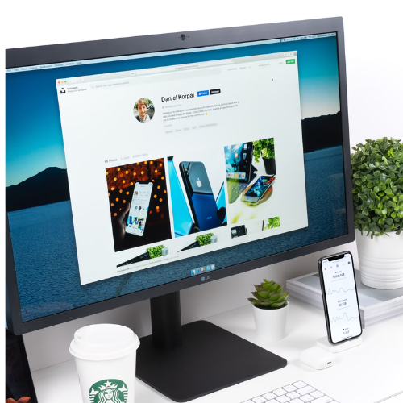  Project name  Website Redesign | Project name  Website Redesign
Project name  Website Redesign | Project name  Website Redesign | Project name  Website Redesign

Price Quote
Below are the costs for your website redesign project. This price quote is valid for 10 working days from today (insert date).

Name | Price | QTY | Subtotal
Inital Discussions | $0.00 | 1 | $0.00
Design Mockups | $0.00 | 1 | $0.00
Design Approval | $0.00 | 1 | $0.00
Web Development | $0.00 | 1 | $0.00
Quality Assurance Stage | $0.00 | 1 | $0.00
Website Launch | $0.00 | 1 | $0.00
Analytics & Marketing | $0.00 | 1 | $0.00
Subtotal:  Government Tax 10%:  Total: |  |  | $0.00  $0.00  $0.00

Invoicing & Bank Details
[Agency name] works with 50% upfront payment. The balance is paid when the project is completed and upon client's complete satisfaction. All invoices issued will be in USD with payment term NET15. For website redesign projects we accept only bank wire transfers. You will find our bank account details enclosed with the project invoices.

Non-discloser of Confidential Information
During this website redesign project some confidential information may be shared between the parties. To make our communication quicker and easier we'll treat all shared information as confidential information. Both parties should take the necessary steps to inform their employees, that sharing of any project-related information with third parties is strongly forbidden.

Governing Law & Arbitration
This Proposal will be governed by the law of the (State of...). Any dispute or claim in connection to a possible breach of this Proposal shall be settled by arbitration in accordance with the rules of arbitration in the (State of...).

[Agency Name]  11 Jan 2022  [Sender Name] | [Client Company]  11 Jan 2022  [Client Name]

