Prepared on: 2022-01-11
Valid until: 2022-01-11
WordPress
Web Design
Proposal
Template
Prepared for:  [Client Name], [Company Name] | Prepared by:  [Sender Name]. [Sender Company

Thank you!

Thank you for considering [Agency Name] as a development partner for your WordPress project. Today it's virtually impossible to grow your business successfully without an online presence and this is what we’ll help you to achieve. [Agency Name] is amongst the most experienced WordPress development agencies in (city). Since the agency was established in 2010 we have been trusted with hundreds of WordPress projects.

For 10 years our team grew from its 2 founders to 20 web developers and designers. Today we cover the whole web development process - web design, front-end development, WordPress integration, training, and post-development support.

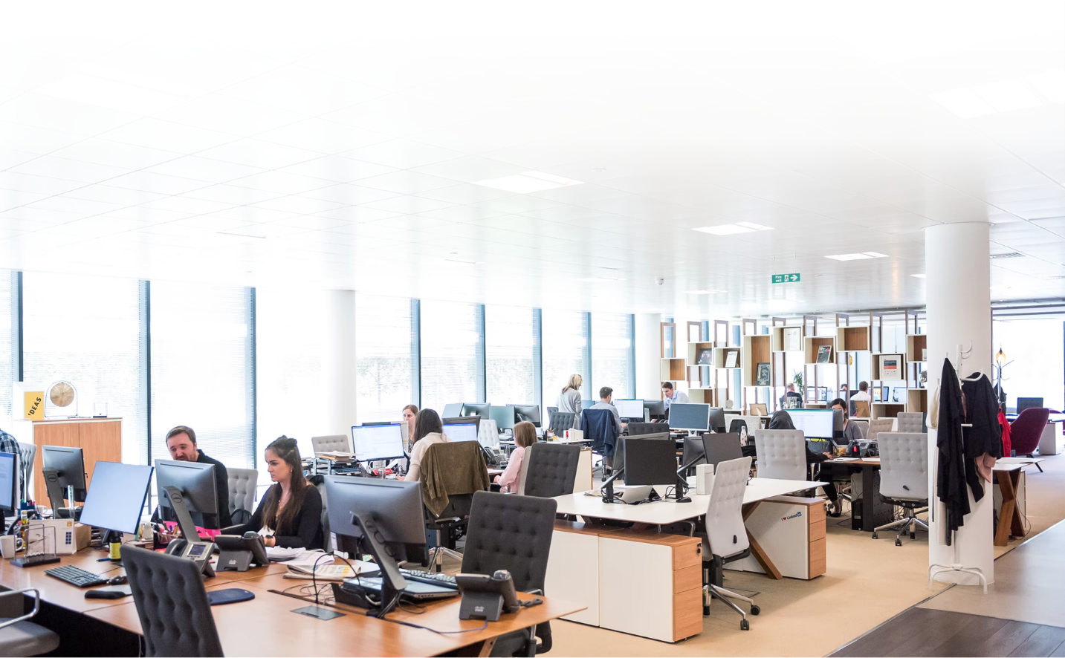
Apart from WordPress development, we also offer web design services, Shopify and Woocommerce integrations, Hubspot and Squarespace integrations, email coding, single-page applications, and mobile development.

Work Process

First, we'll start with the website design. We'll need your brand guideline book as well as to cooperate with your marketing team to work out the best version of your online presence. Then we'll proceed with the coding and the WordPress integration.

- Website Design to fit the [Client Company] brand style
- Frond-End Coding and WordPress Integration
- WordPress admin panel training
- SEO and Online marketing Website

During the admin panel training, we will teach your team how to create new pages, edit texts, titles and images. They'll also learn how to upload content on your Blog and how to adjust its content to meet the best SEO standards.

We'll help you with the marketing of the website and we'll work with you on the marketing campaign for the launch of the new website. The cost for this service is not included in the price quote for the project and the marketing services will be discussed separately in another document.

Success Stories

University of Sonora

The library of the University of Sonora needed an easy-to-use administration pannel to allow the library staff to maintain the large number of titles they have, on their own. We offered to use WordPress for this project and migrated their old website without any of the website’s SEO score being lost. Then we trained their staff how to work with WordPress and today they manage the content of their large website on their own.

SoftEdu

We worked with SoftEdu, one of the leading online education companies in the country, to create their new learning platform for high school students. We worked closely with their team on the designs and UX of the system. Once this first stage was completed we moved on with the programming. The whole project, start to end, took 6 months and the system is currently hosting over 12 000 student accounts.

Projected Cost

Name | Price | QTY | Subtotal
Project Brief Discussion | $0.00 | 1 | $0.00
Website Design | $0.00 | 1 | $0.00
Front-end Development | $0.00 | 1 | $0.00
WordPress Integration | $0.00 | 1 | $0.00
Admin Panel Training | $0.00 | 1 | $0.00
Subtotal:  Government Tax 10%:  Total: |  |  | $00.00  $0.00  $0.00

Payment, NDA & Signatures

We work with a 50% upfront payment before the project is started and another 50% payment upon project completion. The payment term of our accounting team is NET30. For larger-scale projects like yours, we accept only bank wire transfers.

Any information shared during the work process will be considered confidential information. No such information should be shared with third parties, not related to the project development.

By signing this Proposal you commit to working on this project with [Agency Name] and we'll start the first round of consultations as soon as the upfront payment is received.

[Client Company]  11 Jan 2022  [Sender Name] | [Client Company]  11 Jan 2022  [Client Name]

